PROCEDURE PRACTICAL PROBLEM 7:
Group 1:
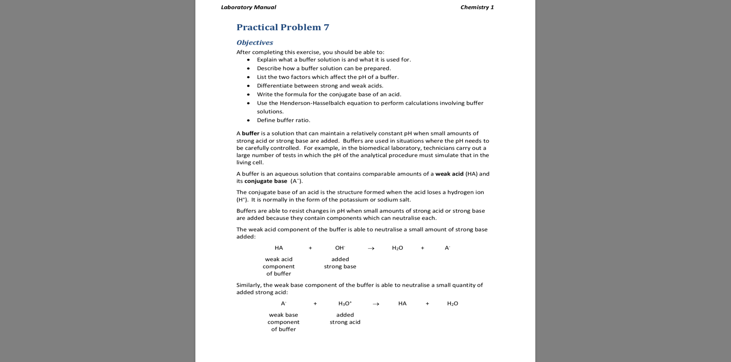
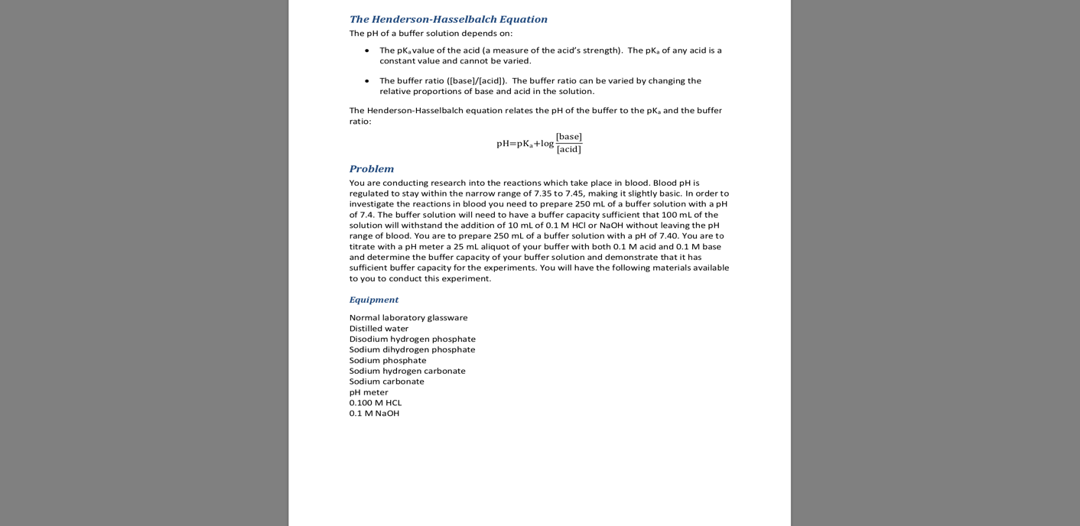
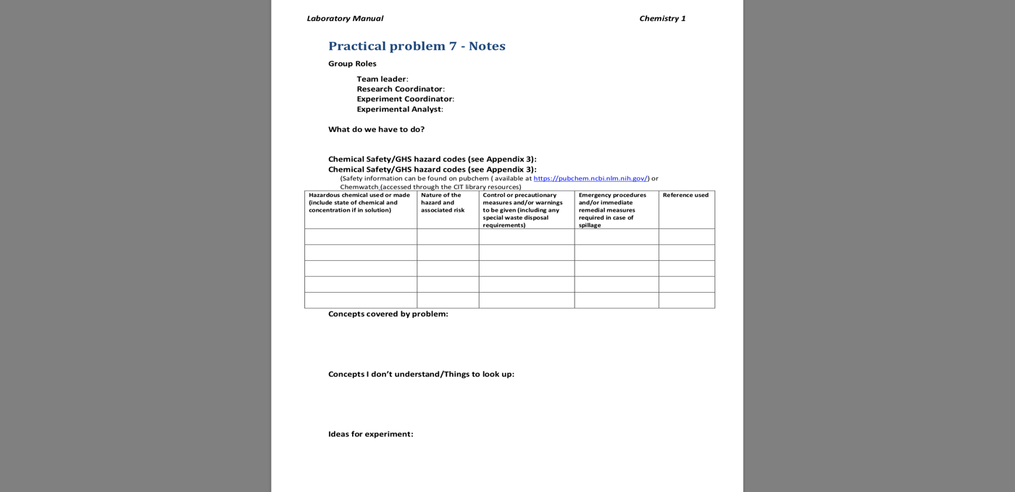
Reactants:

- Distilled water
- Disodium hydrogen phosphate
- Sodium dihydrogen phosphate
- Sodium phosphate
- Sodium hydrogen carbonate
- Sodium carbonate
- Hydrochloric acid 0.1 M
- Sodium Hydroxide 0.1 M

Method:

- Start by weighing approximately 5.6 g of solid disodium hydrogen phosphate (Na2HPO4) and 3.5 g of solid sodium dihydrogen phosphate (NaH2PO4).
- Place the solids in a 0.250 L volumetric flask and add some water, close the flask and gently mix until dissolved, fill the flask to the fill line. This will create a 1.6 M buffer solution.
- Using two 0.050 L volumetric burette, prepare two titrations: one with 0.1 M solution of Hydrochloric acid and another with 0.1 solution of Sodium hydroxide.
- Separate 0.025 L of buffer solution into 8 previously labelled conical flasks, 4 will be used to for the HCL titration and the remaining for the NaOH titration.
- Perform the titrations until you notice a change of 1 PH level (buffer solution sample PH must remain unchanged for and addition of at least 0.0025 L of acid or base).
- Once you have finished the titration collect the data and perform the calculations.

Results: are as follows for practical problem 7:
The results are as follows:
The buffer lotion ph level was 6.88; it was lower than what we needed because we didn’t account for 2 H2O molecules in the sodium dihydrogen phosphate when we made the solution.
For the titration with NaOH 1M solution the results were:
For a NaOH to raise the PH level to 8.01 it needed 23.2 ml; to raise it to 7.92 it needed 22.5 ml
For titration with HCl 1M solution the results were:
For HCl to lower the PH level to 5.91 it needed 28.3ml; to lower it to 5.88 it needed 28.9 ml
Those were the results we got

